**

**Mathematics Specialist Unit 1**

# Test 1b

**Vectors**

|  |
| --- |
| **Name: ______________________ Total Marks:__________** |
|  |
|  |

**Task type: Response**

**Time allowed for this task:** 40 minutes, in-class, under test conditions

Reading time: 3 minutes

Working time: 37 minutes

**Materials required:** Calculator with CAS capability (to be provided by the student)

**Standard items:** Pens (blue/black preferred), pencils (including coloured), sharpener, correction fluid/tape, eraser, ruler, highlighters

**Special items:**  Drawing instruments, templates, notes on two unfolded sheets of   
A4 paper, and up to three calculators approved for use in the WACE examinations

**Marks available: 37 marks**

**Task weighting: 4.5%**

Question 1 [3 marks]

Given **a** = 14**i** + 11**j** and b = 6**i** + k**j**, find the values of k such that│**a**│= 2│**b**│.

Question 2 [4, 3 marks]

a) On the grid below, show the location of the points A to E given that:

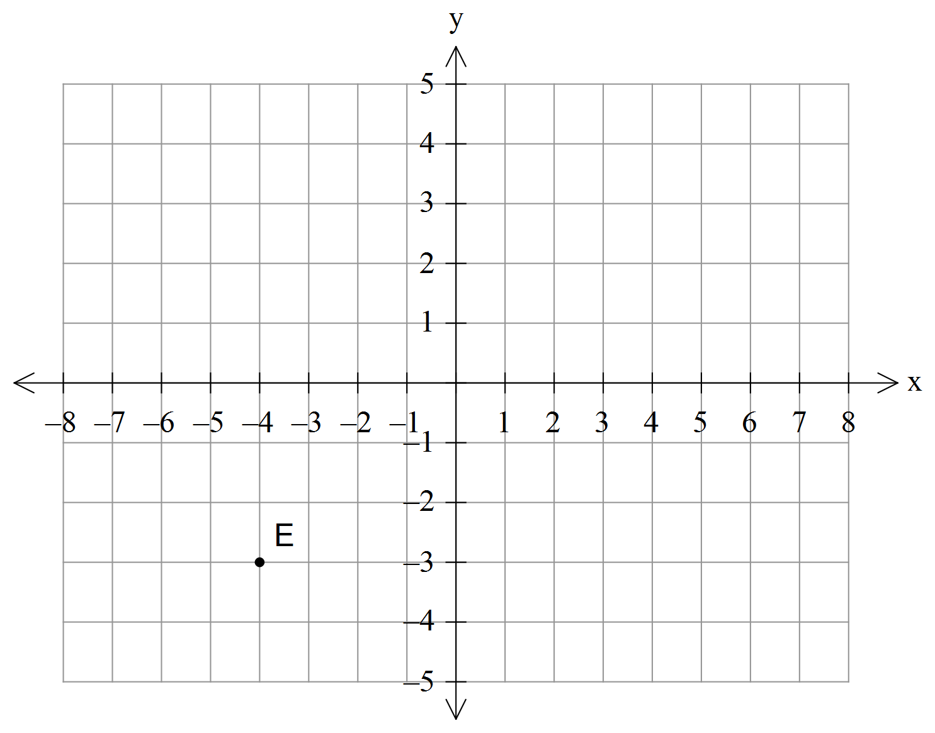[4]

C**r**A = **i** – 2**j**

**r**B = 4**i** - 3**j**

C**r**D = -**i** + 2**j**

A**r**E = 3**i** + 4**j**

b) Ship A has position vector (12**i** – 6**j**) km. Relative to an observer on ship B, ship A has position vector

(8**i** – 8**j**) km. How far is ship B from the origin? [3]

Question 3 [3, 3, 3, 3 marks]

If A(7, -10), B(-5, 6), C(-8, 10) and $D(3, k):$

1. Find the unit vector parallel to $\vec{ BC}$.
2. Show, using vectors, that A, B and C are collinear (i.e. in a line).
3. Find the value of k given that $\vec{BC}$ is perpendicular to $\vec{BD}$
4. Find a point P such that P divides $\vec{AC}$ in the ratio 3:1. (Show full working).

Question 4 [1, 1, 3, 3 marks]

1. Use the scalar product to show that
   1. The vectors $(4, -6)$ and $\left(3, 2\right)$ are perpendicular.
   2. The vectors $\left[\begin{matrix}-1 \\ 3\end{matrix}\right]$ and $\left[\begin{matrix}0.5 \\ -1.5\end{matrix}\right]$ are parallel.
2. Find the size of the angle between 12**i** – 5j and -8**i** + **j**.
3. Determine the vector projection of $3i-j$ onto $-4i+3j$**.**

Question 5 [4 marks]

To Jason who is jogging due East at 8km/h, the wind seems to come from the South with a speed of 5km/h. Find the true magnitude and direction from which the wind is blowing.

Question 6 [3 marks]

Relative to a city, a harbour has a position of $<-21, 63>$ while a lighthouse relative to the city has position

$<2, 17>.$ A fishing boat travels between the harbour and lighthouse at 16km/h. Find the time it takes for this journey.